Havana & Oriental Lilac Cat Club
Newsletter 2017

The Officers and Committee of the Havana & Oriental Cat Club would like to wish all its members both old & new a very Happy & Purrfect New Year

It’s that time of year again, when membership subscriptions are due and you will find a tear off slip to enclose with your payment to the treasurer. To ensure we have your correct details, please complete in full.
We are attempting to keep up with the times and are looking at future payments to be made by paypal, but if you wish to pay by bank transfer, our bank details can be obtained from our treasurer Miss Sue Lloyd
We need your membership to stay a recognised GCCF club and be able to hold a championship show; also this allows us representation at GCCF meetings and breed advisory council meetings.
This year we will be holding our next show on the 7th October, again our show will be open to Orientals and Siamese.
We have a lovely friendly venue, although we may be looking for a bigger venue as again this year we had to turn entries away, so with our home cooked breakfast baps and fresh sandwiches. Hot drinks and home-made cakes etc. Please come and support your breed club.

To be advised if this changes;
Wistaton Memorial Hall
75 Church Lane,
Wistaton,
Crewe.
CW2 8ER

This year has again seen an increase in the number of Havana and Lilacs at the shows which is arousing interest from new potential owners and breeders. It would be really nice to see more of our lovely breeds out at the shows. Breeders are now having more enquiries for kittens

HOLCC 2016 BEST IN SHOW
Best Overall Pedigree Exhibit TOGHAR JHANANDRA (Osh b)
Best Overall Oriental Pedigree Exhibit TOGHAR JHANANDRA (Osh b)
Best Overall Siamese Exhibit PIPPASTRO PURRANORMAL (Olh a 31 33)
Best Overall Household Pet Exhibit IMP GR MC JAKFROST
Best of Variety
Havana & Lilac
Best Adult GR CH HEMLOCK CARIBBEAN-QUEEN (OSH b)
Best Kitten & Overall TOGHAR JHANANDRA (Osh b)
Best Neuter GR CH & GR PR MERRYTAIL SEAPEARL (OSH c)
Any Other Colour Oriental
Best Adult I GR CH FIORDILISO JAYJAY’S JEWELS (OSH n)
Best Kitten ATHELSTAN JOE FABULOUS (OSH a)
Best Neuter & Overall IMP GR CH & GR PR CHANTEUR SHADY LADY (OLH f 11)
Siamese Best Adult & Overall PIPPASTRO PURRANORMAL (Olh a 31 33)
Best Kitten KAMIK WAR-PAINT (Olh f 33 82v)
Best Neuter CH & GR PR WHALLEYBUSH ABRACADABRA (SIA n)
Best Pedigree Pet IMP GR MC JAKFROST
Best Non-Pedigree Pet MC MARLEY

We had a super show with a capacity entry.
Everybody enjoyed the show with fabulous food and a great atmosphere; we hope many of you will join us again this year.
2017 hopefully will see more of our lovely breeds at the shows; we still have a long way to go to keep the required warm chestnut brown sound coats and the intense green eye colour, which the Havana standard requires. As breeders we must strive to keep to the GCCF standard for our breeds.

Photo’s from the show:

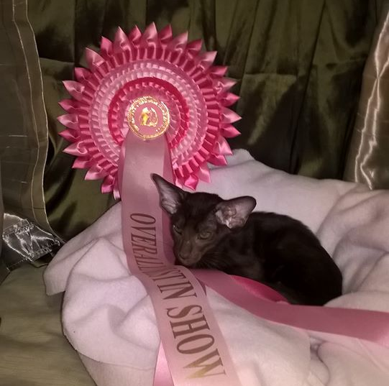
Toghar Jhanandra Overall Best in Show

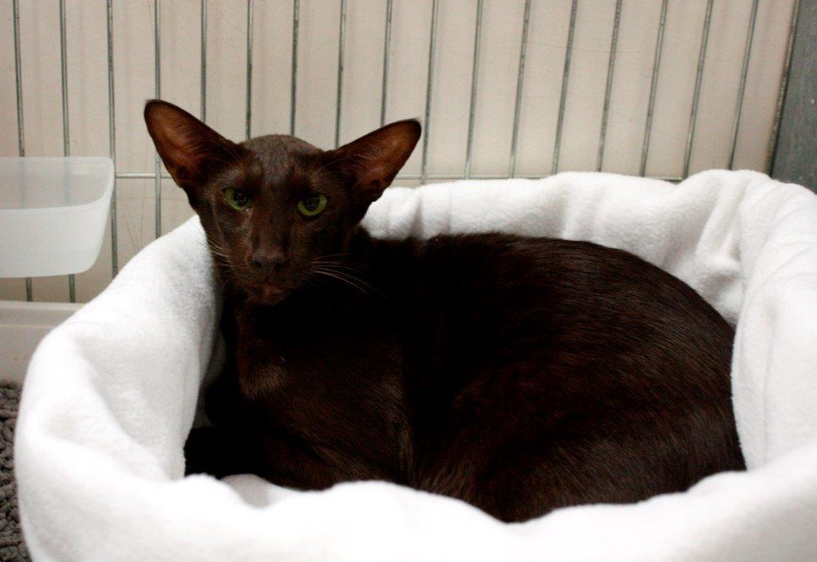
GR CH Hemlock Caribean Queen
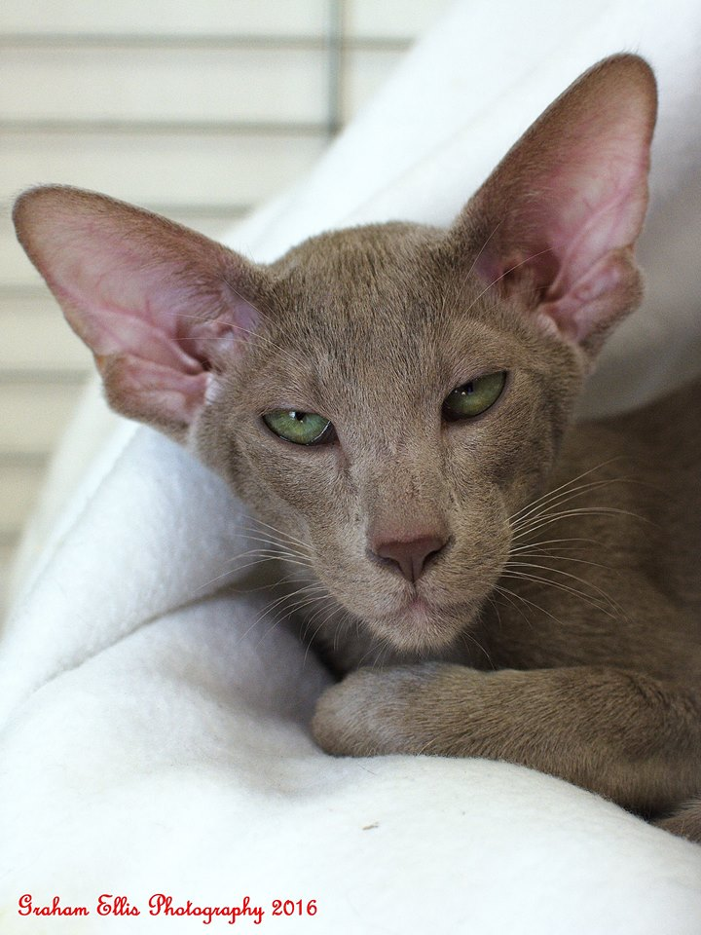
Toghar McIlroy
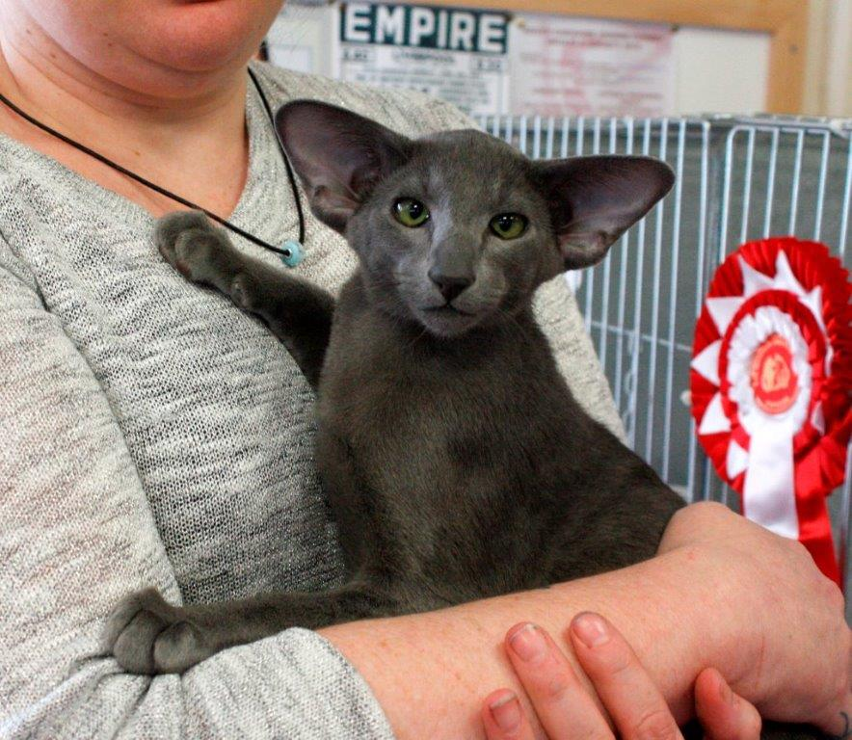
Althelstan Joe Fabulous
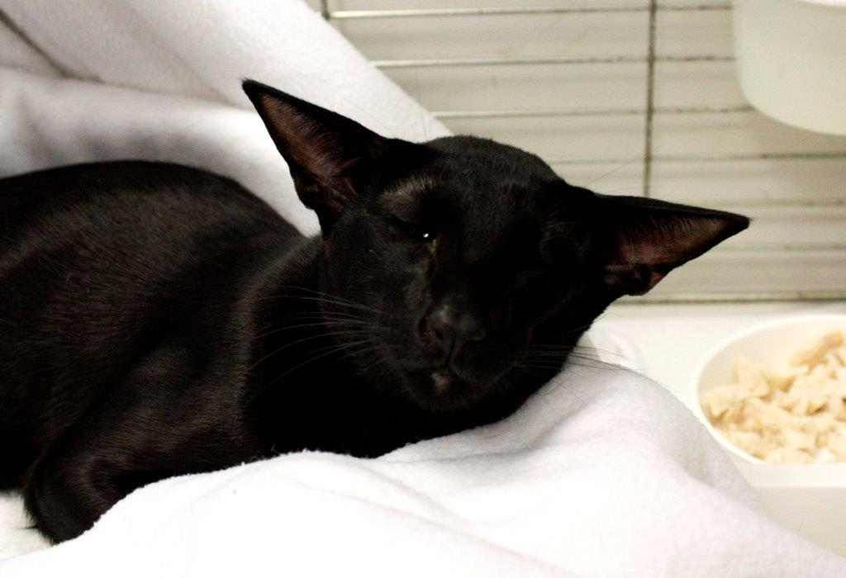
Shimileeta Harlies Rebel

The future looks good with imported new lines strengthening our gene pool, too many people are keeping their studs closed, restrictions etc.; and this does not help with improving our gene pool, just stops the breed advancing into the future. We must encourage new owners to show our lovely babies.
OJBAC
Many breeders are now worried about inbred diseases and the Oriental Breed Advisory committee are being kept up to date on tests and data available for these problems. Any news on these will be published on our website
Website
Please note that our new website is up and running, we will have an up to date breeders list and stud list. Kittens available. Please let us know your details should you wish to be included. There is a small charge of £5 for inclusion on the stud list.
GCCF news
At a recent meeting of the GCCF Council some changes to show rules were proposed (details of the proposals can be found on the website). Although some of these were not adopted there was some indication that the Board could go away and try again. The principle changes are summarised in the following piece.
The most interesting features concern the intention to enhance the Best of Variety and Best In Show Awards. Those who win OVERALL BIS will achieve an additional certificate, and rule changes should ensure show management provide greater clarity on how the selection fo the awards is made and clearly published results. This is only a proposal at this moment in time.
Those aiming for Olympian will also be better informed of just how their cat is doing as the classes will be placed to 5th position.
Other rules changes that exhibitors should familiarise themselves with are the need to clip claws as they will be sent away from vetting in to do it, if necessary.
Exhibitors also need to understand that cats will be withdrawn and possibly excluded from being shown for a time if they display extremely threatening behaviour that indicates biting or that deliberate scratching could happen.
To prevent over handling there will be a limit of six classes at back to back shows, which for titled cats includes the BOB entry, this is now a separate class to be included in the maximum allowed to be entered.
Also exhibitors should not enter a breed in the pedigree pet section that is accepted by other organisations, but not a pedigree breed recognised by GCCF. It could be rejected at vetting in or not judged in its certificate class. The intention is that breeds based upon physical anomalies or species outcrosses do not inadvertently turn up on the show bench when there is little chance that they would ever be recognised GCCF breeds. These new rules come into effect on 1st January 2017All future males to be registered on the GCCF entirety list must now be micro chipped; this does not apply to males already on the active list.

HOLCC AGM
Will be held on April 1st 2017 - Time 14:00
At
94 Meadow Lane
Trentham, Stoke on Trent
ST4 8DJ
WE URGENTLY NEED NEW COMMITTEE MEMBERS,
Remember – no committee – no club – no show.

Just thought I would add a little recipe for you to use up all those uneaten walnuts and bananas from Christmas.

BANANA & WALNUT MUFFINS (makes 12)
200grms Caster Sugar
120ml Vegetable oil
1 Egg
3 Ripe Bananas mashed
30grms Chopped Walnuts
250grms Plain flour
1 teasp Bicarbonate of Soda
Half teaspoon salt
Method
- Preheat oven to 180C / Gas 4. Place bun cases in muffin tin
- Mix sugar, oil and egg until creamy and light yellow, add bananas and walnuts, add flour, bicarbonate of soda and salt. Stir until completely smooth. Spoon batter into the muffin cases evenly.
- Bake for 30 to 40 minutes, until a skewer poked in centre comes out clean.
- Enjoy………………………

HOPE WE SEE YOU AT THE 2017 SHOW

And remember:-
“LIFE WITHOUT CATS

I DON’T THINK SO”

PS. Your editor needs stories and topics to put in the newsletter.

MEMBERSHIP
Send Subscriptions to: Single: £7.00 Joint: £10.00.

Please complete details below and send subscriptions with tear off section to assist in updating our records.
We would in the future like to set up bank transfer facilities for subscriptions but if you wish to pay by bank transfer our details are available from:

Miss S Lloyd HON treasurer.
Broomcroft, Mill Lane,
Stoney Middleton, Hope Valley,
Derbys. S32 4TS
susan_lloyd@btopenworld.com

-----------------------------------------------------------------------------------------------------------------------------------------------------------
2017 Subscription HOLCC

Name................................................................................................Prefix..................................

Address.......................................................................................................
....................................................................................................................

Tel No:.................................... Email .........................................................................

Please tick this box if you do not wish to be emailed newsletters etc.

